Research portfolio
College of Fisheries and Life Science,
Shanghai Ocean University
Shanghai China

ASSIGNMENTS FEBRUARY 2017 –FEBRUARY 2017
contents
Brief introduction on Shanghai Ocean University-------------------------------------------3
Brief introduction on College of Fisheries and Life Science, SOU-----------------------8
Research topics----------------------------------------------------------------------------------9
- Reservoir and Lake Ecology ------------------------------------------------------------- 9
- Assimilation of carbon, nitrogen and phosphorus in Undaria----------------------9
- Growth, thermal and salt tolerance traits and genetic diversity of families of Sinonovacula constricta------------------------------------------------------------9
- Oral administration of Anabaena-expressed VP28 against white spot syndrome virus in shrimp-----------------------------------------------------------------------------10
- Isolation and selection on high Amonia resistant microalgae strains---------------11
- Valuation on growth of the shrimp Litopenaeus vannamei in different microalgae water-----------------------------------------------------------------------------------------11
- Nutritional manipulation on Isochrysis galbana in cylindrical photobioreactor--12
- Safety assessment of transgenic zebrafish from metabolites and metabolic pathways------------------------------------------------------------------------------------13
- Bacteria-Mussel Interactions------------------------------------------------------------13
- Integration of p38MAPK and BMPs signaling pathway during zebrafish oocyte maturation---------------------------------------------------------------------------------14
- Sex control in tilapia--------------------------------------------------------------------14
- Feeding juvenile freshwater mussel---------------------------------------------------15
- Study on Tetrodotoxin biosynthesis----------------------------------------------------16
- The effect of different sampling strategy on detecting environment DNA in freshwater systems----------------------------------------------------------------------16
- Artificial reproduction of Japanese eel Anguilla japonica------------------------17

1 Brief Introduction on Shanghai Ocean University
Shanghai Ocean University, which was formerly Jiangsu Provincial Fisheries School established in 1912, is a university with 102-year history and glorious tradition. In 1952, it became the first fisheries college, namely, Shanghai Fisheries College and was renamed in 1985 Shanghai Fisheries University. In 2008, it was renamed Shanghai Ocean University. It has developed into a multi-disciplinary university focusing on the coordinated development in agriculture, science, engineering, economics, arts and management with complete disciplines and distinguishing features.
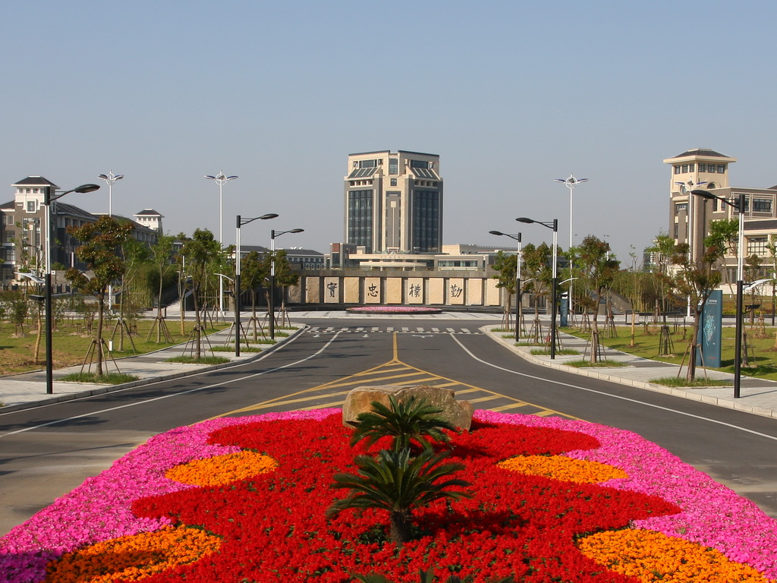
The university consists of 8 specialized colleges, namely, College of Aqua-life Science and Technology, College of Marine Science and Technology, College of Food Science and Technology, College of Economic Management, College of Information Technology, College of Humanities, College of Engineering, and College of Foreign Languages as well as other 4 colleges, including College of International Cultural Exchange, College of Continuing Education, College of Higher Technical and Vocational Education, and the joint IEN Institute by the University and Australia. In addition, the Central Agricultural Cadres Training Center, SHOU Branch and the Ocean Fisheries Training Center of Ministry of Agriculture are also located in the university.
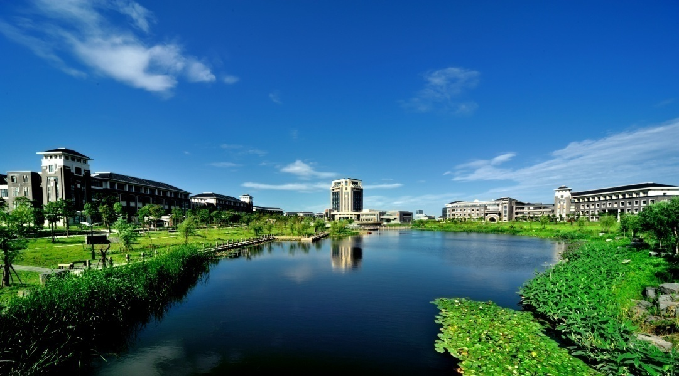
The university has 1 national key discipline, 10 provincial and ministerial key disciplines, 1 educational highland of Shanghai and 1 E Institute of Shanghai Universities. It has one postdoctoral station, 1 doctoral program of the first-level discipline, 7 doctoral programs of the second-level disciplines, 2 master program of the first-level discipline, 23 master programs of the second-level disciplines, 7 equivalent-education master programs, 43 bachelor programs and research directions.
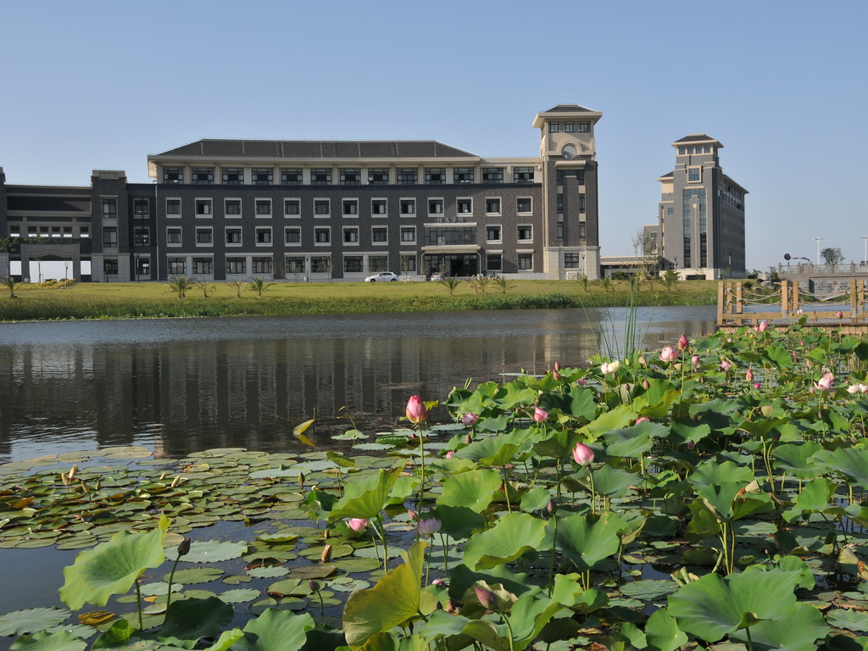
There are 12,700-odd undergraduate students and 1200 postgraduates enrolled in the university. Among 1040 work staff members, there are 680 teachers and scientific researchers, including 400 with senior titles and 343 master and doctoral supervisors. There is one professor from the University acting as the counselor in the Academic Degree Appraisal Board of the State Council, and another one selected in the State Project of Hundred, Thousand, and Ten Thousand Talents. In addition, 2 and 3 teachers are respectively awarded the honorary title of the State Distinguished Young-and-Middle-Aged Expert and the title of the Provincial or Ministerial Distinguished Young-and-Middle-Aged Expert. Another 4 act as members in the 7th Session of the Science and Technology Commission of the Ministry of Agriculture, and 1 act as member in the 8th Session.
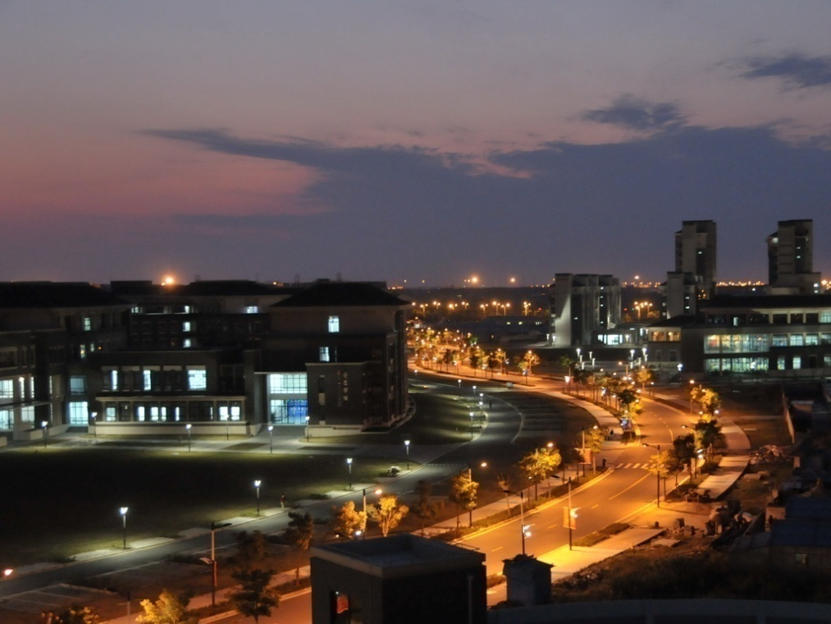
Enjoying good facilities for education and complete laboratories and special experimental equipment, the university owns the Key Open Laboratory of Aquatic Genetic Resources Excavation and Utilization of the Ministry of Education, the Key Open Laboratory of Aquatic Genetic Resources and Aquaculture Ecology of the Ministry of Agriculture, and the Bank and Refrigeration Center of Aquatic Animals and Plants Pathogens of the Ministry of Agriculture. The university has established such special laboratories as Laboratory for Fresh Water Fish Processing and Utilization Research, and Oceanic Fishery Remote Sensing and Information Research Center as well as 7 research centers at the university level. Besides, the university owns the Agriculture Research Institute of SHOU, Research Institute of Public Administration, Research Institute of China Ichthyological Culture, Museum of China Ichthyological Culture, Ichthyology Research Institute and Specimen Laboratory renowned home and abroad, and Museum of Whales, which is the biggest and a special one in Asia. The library has a total storage of 845,000 books and 389,000 electronic books featuring fishery, marine science and food. Owning a modern campus network, the university has established a platform China Fisheries Network serving the fisheries industry of our country. Journal of Fisheries and Journal of SHOU sponsored by the university are listed as key Chinese journals, China key scientific and technological journals and China scientific and technological papers citation source journals. Journal of Fisheries has been awarded the title of the first and second session of one hundred excellent academic journals of China.
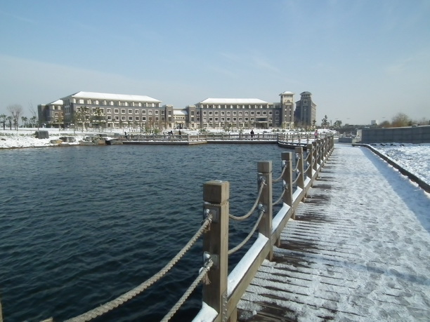
Since 1990s, there are over 50 scientific and technological achievements leading the world, over 80 belonging to innovation or leading the country, over 40 awarded the state-level prizes and over 50 the provincial or ministerial-level prizes. In addition, over 30 patents have been achieved. The university has made great contribution in such fields as environmental protection, species protection, genetic breeding, food processing, marine resources development and utilization, aquaculture, agricultural economy and so on.
The university has built a close relationship and cooperation with the universities of the U.S.A, Japan, Russia, and Australia, as well as several international organizations. The university has exchanged overseas students with universities in several countries, participated in the Sino-US cooperative projects of marine living resources for a long period, and established a long-period and friendly cooperation with such international organizations as the United Nations Food and Agriculture Organization, UNESCO, Fisheries Information Center, Asian Fisheries Society, and International Aquatic Living Resources Management Center, etc.
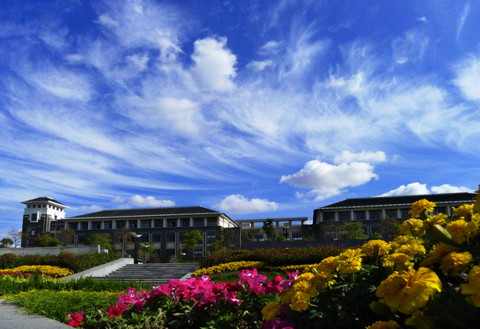
The university makes full use of its geographic advantage in Shanghai, opening further to the world and strengthening cooperation with international universities and institutions. We have established cooperative relationships with 45 institutions and organizations from 16 countries or regions.
College of Fisheries and Life Science
Founded in 1921, the College of Fisheries and Life Science, with 94 years history, is the former Aquaculture Branch of Jiangsu Provincial Fisheries School. It has 3 disciplines, namely, Aquaculture, Aquatic Biology and Marine Biology, with 7 subordinate departments. It has established the Key Open Laboratory of Aquatic Genetic Resources and Aquaculture Ecology of the Ministry of Agriculture, the Key Open Laboratory of Aquatic Genetic Resources Excavation and Utilization jointly constructed by the university, the Municipality and the Ministry of Education, the Bank of Aquatic Animals and Plants Pathogens of the Ministry of Agriculture , Fish Nutrition and Environment Research Centre, Shanghai University Program Research Centre of Water Environment and Ecology, Shanghai Aquaculture Program Technical Research Centre, National Fisheries Science Experimental Teaching Centre, Aquaculture E-Institute of Shanghai Universities, the Ichthyologic Research Lab and Specimen Lab. It also has 2 educational bases in Binhai, Pudong District and Xiangshan, Zhejiang Province, 2 school-level enterprises-universities-researches cooperative bases and 12 Practical Training Bases for undergraduate students.
The Aquaculture was appraised as the National Key Discipline as well as the Key Discipline of Shanghai Municipality and the Ministry of Agriculture. The college has one postdoctoral station and 2 doctoral degree programs in aquaculture and aquatic biology, 7 master degree programs and 8 bachelor degree programs.
Students that are interested in an internship, research minor or final thesis at College of Fisheries and Life Science can apply by sending a motivation letter. Motivation letters are to be sent preferably before Oct. 14th 2015. Please send your letter to the contact person: Xuxiong Huang – xxhuang@shou.edu.cn

2 Research topics
Reservoir and Lake ecology
- Studying the interaction between carps (silver carp and bighead) and lake (reservoir) environment (as a non-traditional biomanipulation), not only focusing on the effects of carps on phytoplankton, but the nutrients (N and P) cycling and cyanotoxin also.
In this programs, we are doing both control experiment in ponds, bay of reservoirs, or whole lake experiment. Students can learn how to monitoring water quality (water chemistry), phytoplankton, zooplankton and other organisms (such as bacteria and fish etc.) Interactions among different fish or between biological and abiotic factors are also included. Dynamics of fish population are also one of the studied topics.
- A mechanical or physical treatment of blue-green algal bloom in small reservoirs. Monitoring program and optimization the treatment are under study. Students may be involved in the monitoring tasks.
- Studies on the ecological mechanisms of fish-rice integrated or co-producing ecosystems. Studies on the fish-rice interaction and its effects on water quality and emission of green house gas etc.

Research type: literature study, modelling
Research level: minor/ internship/final thesis (both BSc. and MSc. level)
Prerequisite: good understanding of aquatic ecology, fish biology; good analytical and mathematical skills; good communication
Researcher involved: Professor Liu
Period: September 2016 - September 2017

Assimilation of carbon, nitrogen and phosphorus in Undaria
China and many other countries are dealing with rapidly increasing nutrients in coastal waters. Algae can help to carbon sequestration and remove nutrients from coastal waters, providing the opportunity to mitigate the risks posed by environmental change. Undaria pinnatifidais widely distributed in coastal areas of Liaoning, Shandong and Shengsi islands of Zhejiang,China, which have considerable economic importance as food source in China.
This research involves literature research to obtain information about Undaria pinnatifida and its reproduction cycle. Based on literature and a general reproduction protocol for seaweed, explorative lab experiments to reproduce Undaria pinnatifida will be carried out in the Culture Lab. And the rate of photosynthetic oxygen evolution, the rate of nutrients((NH₄⁺, NO₂⁻ and NO₃⁻, phosphorus) assimilation of Undaria pinnatifida measurement will be carried out.
The aim of above programs is to evaluate the carbon and nutrients removal capacities of algae farms and evaluate its ecological effects.

Research type: literature study, experiments
Research level: minor/ internship/final thesis (both BSc. and MSc. level)
Prerequisite: good understanding of biology/ecology/chemistry; good analytical skills; good communication
Researcher involved: aquaculture, biology, ecology
Period: April 2017 - September 2017

Growth, thermal and salt tolerance traits and genetic diversity of families of Sinonovacula constricta
Sinonovacula constricta is widely distributed in coastal areas of China. It is a traditional Chinese bivalve which can accommodate wide temperature and wide salinity. The development of its aquaculture industry has last hundreds of years. The seed resource of S. constricta is mainly obtained by the semi artificial seed selection for a long time. In recent years, the technology of S.constricta industrial feeding has achieved a breakthrough. The large-scale indoor seedling technology is becoming mature, but still lack of the improved varieties which are raised through artificial breeding. Therefore, the genetic improvement for S. constricta and raised new varieties with fast growth speed and distinct individual character through artificial breeding is an important way to solve the problem.
In our laboratory, some programs associated with razor clam growth,thermal and salt tolerance traits and genetic diversity include:
Families of Sinonovacula constricta, including combinations between several full-sibs families and few maternal half-sib families, are established through artificial induced spawning .
Analyzing the relativity of phenotypic character of S. constricta and comparing the growth character at different day-age, it can be selected or hybridized to breed bigger and faster-growth families.
Genetic analysis to these families is based on 9 microsatellite markers. The result will shows that the polymorphism information content in 9 microsatellite sites ,the average valid number of alleles will be measured as so as the valid proportion of alleles .Cluster analysis shows that coefficient of heredities of family ,the genetic structure of the offspring.
To investigate the relationship between growth properties and thermal and high salt tolerance in families of S. Constricta.
The aim of above programs is to understand the present techniques and improve it or develop new technique for future razor clam breeding.
Research type: literature study, experiments
Research level: minor/ internship/ final thesis (both BSc. and MSc. level)
Prerequisite: good understanding of biology/genetics; good bioinformatics; good communication
Researcher involved: aquaculture, genetics
Period: September 2017 - February 2018
-----------------------------------------------------------------------------------------------------------------------------------------

Oral administration of Anabaena-expressed VP28 against white spot syndrome virus in shrimp
White spot syndrome virus (WSSV) is one of the most prevalent and lethal for shrimp, and oral administration of vp28 is a promising approach to protect shrimp against WSSV. Although seven heterologous expressions have been successful since 2004, no one has been commercialized in shrimp industry.
This research involves literature research to obtain information about cyanobacterium， white spot syndrome virus and its vaccine. Based on literature and a general reproduction protocol for cyanobacterium, explorative lab experiments to reproduce cyanobacterium will be carried out in the Culture Lab. And the effects of using the mutant as both drug and feed for the post larvae of Litopenaeus vannamei against WSSV, and the optimal growth conditions of the wild type and mutants of Anabaena sp. PCC 7120. will be carried out.
The aim of above programs is to evaluate that the post larvae of shrimp were enhanced protection against WSSV after oral administration of vp28 expressed in Anabaena sp. PCC 7120

Research type: literature study, experiments
Research level: minor/ internship/ final thesis (both BSc. and MSc. level)
Prerequisite: good understanding of biology/molecular biology/biochemistry; good analytical skills; good communication
Researcher involved: aquaculture, biology, molecular biology
Period: April 2017 - September 2017
------------------------------------------------------------------------------------------------------------------------------------------
Isolation and selection on high Amonia resistant microalgae strains
There are many microalgal species in different nature habitats. Microalgae is of versatility and could be developed as feedstock of new generation biodiesel, live feed for aquatic animals, media for sewage treatment, material for pharmaceutical production and so on. Recently, purification on sewage from piggery with microalgae is one of the highlights on microalgae research in China. The piggery sewage is characterized with high amonia content. So isolation and selection on high amonia resistant microalgae strains is the first step for purification on piggery sewage.
In this study, microalgae strains will be sampled from different water and the microalgal clones will be isolated in lab with various measures. Then the morphology and classification of the microalgae strains will be described. The suitable culture conditions of the clones will also be investigated. Finally the resistances and purification of the microalgae clones to high amonia water will be assessed for selecting the microalgae strain which is suitable and could be applied in piggery sewage purification.
Research type: experiments
Research level: minor/ internship/final thesis (BSc.)
Prerequisite: good understanding of biology/chemistry; good analytical skills; communicative
Researcher involved: biology
Period: 2nd semester 2016-2017
-------------------------------------------------------------------------------------------------------

Valuation on growth of the shrimp Litopenaeus vannamei in different microalgae water
The white shrimp Litopenaeus vannamei is worldwide cultured crustacean due to its characteristics such as fast growth, widely adaptability, short culture period, and popular market. In the past few years, culture on the white shrimp in China developed rapidly. The annual output achieved at about 500000 tons in 2007, which accounted for more than 60% of the total shrimp production in China. However, the sustainable development of this shrimp farming in China is facing severe challenges which caused by stress and germplasm degradation in intensive culture. In practice the shrimp growth and survival seems to be related to the microalgae community in the culture water. It has been demonstrated that different microalgae as well as its biomass in water displayed different inhibition to proliferation of the pathogen Vibrio, which usually is regard as the killer of the shrimp in most case. Whether we can avoid failure in shrimp production by optimizing the microalgae community need to be verified in experimental scale.
In this study, larval white shrimp will be randomly distributed in the four tanks which were inoculated with species of Cyanophyta, Bacillariophyta and Chlorophyta respectively. The biomass of the microalgae in water will be adjusted with filter facilities and Vibrio counts in water will be investigated periodically during the experiment. Then the growth performance, survival, feed conversion rate and immune activity of the shrimp will be assessed. The aim of the study is to collect basal data on sustainable production of the white shrimp via ecological manipulation.
Research type: experiments
Research level: minor/ internship/final thesis (BSc.)
Prerequisite: good understanding of biology/aquaculture; good analytical skills; communicative
Researcher involved: aquaculture
Period: 2nd semester 2016-2017
-------------------------------------------------------------------------------------------------------

Nutritional manipulation on Isochrysis galbana in cylindrical photobioreactor
The microalgae Isochrysis galbana is the popularized live feed which is applied in nursery and culture of invertebrate aquatic animals such as oyster, clam, shrimp, rotifer and so on due to its digestibility and high nutrition (containing high levels of DHA and EPA). It has been demonstrated that the nutritional value on microalgae could be manipulated by changing microalgae culture conditions. The survival and growth performances of the aquatic animals are closely related to the nutrition of the microalgae. Cylindrical photobioreactor is one of the suitable equipment for commercial microalgae production with advantages as high productivity, easy cleaning and relative low production cost. So nutritional manipulation on Isochrysis galbana in cylindrical photobioreactor became an interesting topic for aquaculturist.
This study will deal with the nutritional manipulation on microalgae Isochrysis galbana in cylindrical photobioreactor. based on the results on single factors experiments, the combined effects of several culture parameters (nutrient, salinity, culture time and so on) on the nutrition contents of the cell will be investigated. The aim of this study is to determine the combined culture conditions in cylindrical photobioreactor under which the microalgae Isochrysis galbana accumulate high nutrition (especially highly unsaturated fatty acids) in cells.
Research type: literature study, experiments
Research level: minor/ internship/final thesis (BSc.)
Prerequisite: good understanding of biology/chemistry; good analytical skills; communicative
Researcher involved: aquaculture
Period: 2nd semester 2016-2017
-------------------------------------------------------------------------------------------------------

Safety assessment of transgenic zebrafish from metabolites and metabolic pathways
Transgenesis is the process of introducing an exogenous gene ( or a transgene) into a living organism so that the organism will exhibit a new property and transmit that property to its offspring. This organism is called a genetically modified organism (GMO), also known as a transgenic organism.
Transgenic organisms are the source of genetically modified foods and are also widely used in scientific research. So far no reports of ill effects have been proven in the human population from ingesting genetically modified food. However, people still concern the potential long-term impact on human health from food derived from GMOs.
The zebrafish (Danio rerio) is a tropical freshwater fish. It is an excellent vertebrate model organism in scientific research, particularly in tissue regeneration, sex reversal and cell transplantation. Our laboratory has generated a variety of fluorescence-labeled transgenic strains. Earlier researches by students revealed promising techniques for visualization of transgene-reporter and metabolism detection.
For this topic, the aim is to understand how the transgenic product is metabolized in fish body after its ingesting a transgenic fish. The metabolism process could be investigated in two ways: histological observations and transcriptome linked metabolite analyses.
Research type: literature study, experiments
Research level: minor/ internship/final thesis (both BSc. and MSc. level)
Prerequisite: good understanding of cell biology, biochemistry, good analytical skills; communicative
Researcher involved: research group biotechnology (Jizhou Yan and Hao Wu)
Period: 2nd semesters 2016-2017
-------------------------------------------------------------------------------------------------------
Bacteria-Mussel Interactions
Mytilid mussels are important fouling and aquaculture species, and widely distributed in inter- and sub-tidal habitats around the world. As with many other marine invertebrates, mussels possess a planktonic larval stage preceding a benthic adult phase. Once larvae become competent, they will settle and metamorphose if the larvae encounter suitable environmental conditions. The larva involves a change in habitat during which larvae settle in juvenile environment. This is followed by larval metamorphosis, which is an irreversible developmental phenomenon. These critical steps of development are influenced by many endo- and exogenous biotic factors, and also by exogenous abiotic factors. Biofilms, existing on almost all exposed substrata in the marine environment, have been viewed as cues to appropriate settlement sites by larvae of many marine invertebrates. Marine biofilms are composed chiefly of multiple bacterial species, which are the initial biological colonizers of new surfaces in the sea, plus diatoms, fungal filments, protozoans, and undoubtedly other microorganisms. Bacteria in marine biofilms play an important role in the recruitment of many marine invertebrate species by producing cues to settlement for marine invertebrate larvae. However, the interaction between bacteria and mussel settlement remains unknown. Thus, the topic is “Bacteria-mussel interactions”.
The purpose of this study is to promote the understanding how marine bacteria influence the settlement of the mussel.
Research type: Experiments
Research level: Internship
Prerequisite: Good understanding of biology/microbiology; communicative
Researcher involved: Research group Marine Organisms (Dr. Jin-Long Yang)
Period: 2nd semester 2016-2017
-------------------------------------------------------------------------------------------------------

Integration of p38MAPK and BMPs signaling pathway during zebrafish oocyte maturation
The BMPs (bone morphogenetic proteins, BMPs) signal pathway is the key reproductive regulator in vertebrates. p38MAPK is a member of mitogen-activated protein kinase(MAPK) superfamily playing crucial roles in oocyte development and maturation in mammals. While we have learned much about the classical BMPs-Receptor-Smad signaling pathway of BMPs regulation follicle development and maturation such as BMP15 and GDF9, virtually nothing is know about the activating Smad-independent signal pathway in zebrafish ovaries. This project will design to investigate 1) whether BMPs can activate p38MAPK signal transduction pathway in ooycte maturation; 2) the effect of inhibition of p38MAPK signaling pathway on BMPs induced-oocyte maturation.
Research type: Experiments
Research level: Internship
Prerequisite: Good understanding of biology/microbiology; communicative
Researcher involved: Research group Marine Organisms (Dr. Jin-Long Yang)
Period: 2st semester 2016-2017
-------------------------------------------------------------------------------------------------------

Sex control in tilapia
Tilapia is one of the most popular fish in the world (both in developing countries and developed countries) for its stable supply of the animal protein. Since the male tilapia fish grow faster than the female, and early breeding in the mixed sex tilapia culture would also decrease the production. Therefore, the single sex (male) production is of great importance for tilapia farming. Presently, several sex control techniques have been developed, for example, hormone induction, inter-specific hybridization, YY chromosome male, temperature induction, and physical control. In our laboratory, some programs associated with tilapia sex control include:
Tilapia sexual identification in morphology, histology and molecular marker
Mouth-hatching and artificial hatching of fertilized eggs
Hormone induction and temperature induction at larval stage
Hybridization between different tilapia species
X, Y chromosome identification
The aim of above programs is to understand the present techniques and improve it or develop new technique for future tilapia production.
Research type: literature study, experiments
Research level: minor/ internship/ final thesis (both BSc. and MSc. level)
Prerequisite: good understanding of biology/chemistry; good analytical skills; good communication
Researcher involved: aquaculture, biology
Period: 1st semester 2016-2017
-------------------------------------------------------------------------------------------------------

Feeding juvenile freshwater mussel
Hyriopsis cumingii has become even more important for commercial freshwater pearl production in China, with current annual production reaching 1,200 metric tons. This accounts for more than 95% of the total production worldwide, with more than 90% produced by H. cumingii. In order to satisfy great seed demand for freshwater pearl mussel aquaculture, its artificial propagation in 1979. But the traditional artificial propagation, which water and fresh algae directly supplied from outdoor earth pond, is half-intensive, the annual yield is limited by climate. We designed one circulating system, including juvenile mussel culturing unit and fresh algae supplying unit, in greenhouse. For sufficient diet supplying for culturing juvenile mussel, especially the later stage, large greenhouse is needed for fresh algae supplying unit. The cost become higher as the land price increasing. Adding some supplementary diet for culturing juvenile mussel may accelerate mussel growth and decrease the cost. In another side, many freshwater mussel are endangered species in the world. This juvenile mussel culturing system will be beneficial endangered freshwater mussel propagation and resource protection.
The aim of this study is to evaluated different supplementary diets for juvenile freshwater pearl mussel production. During this study, several algal, photosynthetic bacteria, yeast powder and their combination will be tried and the production of mussel on these diets will be monitored (growth, shell nacre color and mortality).
Research type: literature study, experiments
Research level: minor/ internship/final thesis (BSc. level)
Prerequisite: good understanding of biology/chemistry; good analytical skills; communicative
Researcher involved: research group for freshwater pearl mussel aquaculture and breeding
Period: 2nd semester 2016-2017
-------------------------------------------------------------------------------------------------------

Study on Tetrodotoxin Biosynthesis
The neurotoxin tetrodotoxin (TTX) has a potential use in anaesthesia and analgesia as its selectively blocking voltage-gated sodium channels. TTX has been identified from taxonomically diverse marine organisms, mainly produced by symbiotic bacteria. However, TTX biosynthesis has yet to be elucidated. Very few studies have been performed that address the cellular production of TTX. Because of the guanidinium moiety of TTX, arginine has been supposed to be the substrate of TTX. Apart from the feeding study using arginine to feed pufferfish in one study, there has been virtually no research into the origin of the guanidinium moiety of TTX. Our lab has collected several bacterial strains with TTX-producing capable. We plan to culture the strains using different concentration of arginine or isotope labeled arginine to trace the TTX biosynthesis pathway. Moreover, we will try to compare the transcriptomes among these different TTX-producing bacteria to identify the candidate TTX biosynthesis enzymes.
For this topic two research possibilities are therefore open:
•A. Substrate screening for tetrodotoxin biosynthesis in TTX-producing bacteria
B. Gene screening on genes coding the TTX biosynthesis enzymes
The aims in research possibilities are to determine the substract of TTX biosythesis and at least one candidate gene encoding TTX biosynthesis enzymes.
Research type: experiments (SOU, Shanghai)
Research level: minor/ internship/final thesis (both BSc. and MSc. level)
Prerequisite: good understanding of microbiology/molecular biology; good analytical skills; communicative
Researcher involved: Research group of Development and Evolution Biology (Baolong Bao)
Period: 1st semester 2016-2017
-------------------------------------------------------------------------------------------------------

The effect of different sampling strategy on detecting environment DNA in freshwater systems
Environmental DNA (eDNA) is free DNA mostly found in water body, soil or other ambient media, which is released from the saliva, mucus, injured wounds, scales, sperms, eggs and other body parts. Extracting eDNA and determining the sequence could help in detecting the presence of species and to some extent evaluating their relative abundance. Utilizing eDNA is astate of arts tool in monitoring invasivespecies, conservingendangered species, and understanding community and ecosystem diversity. Along with the fast developing of applications using eDNA, there are also numerous challenges in lab techniques and data analytic approaches related to eDNA, such that, systematically evaluating sampling strategy is urgently need for detecting eDNA in freshwater systems.
The goal of this study is to estimate the effect of different sampling strategy to retrievable eDNA data. A series experiment concerning the sampling sites, targets and DNA extracting methods will be carried out. The expertises held in our lab include molecular marker development, DNA extraction,DNA library preparation and target gene capture. Ultimately, we plan to develop sampling strategy and lab techniquesfor using eDNA for long-term biodiversity monitoring program.
Research type: Combination of fieldwork, lab work and data analysis
Research level:Internship/final thesis (both BSc. and MSc. level)
Prerequisite: Good understanding of biology/chemistry, analytical skills
Researcher involved: Molecular systematic and ecology group (Chenhong Li, http://smxy.shou.edu.cn/1f/67/c2054a139111/page.htm)
Period: 2nd semester 2016-2017
-------------------------------------------------------------------------------------------------------

Artificial reproduction of Japanese eel Anguilla japonica
Remarkable progress in techniques for maturation of adults and rearing of larvae has been achieved forthe Japanese eel Anguilla japonica over the past 50 years, but recent efforts have not yet succeeded in the massproduction of glass eels.Recent advancements oftechniques for the artificial maturation of adults andlarval rearing of A. japonica will be reviewed. Migratory eels will be harvested from Yangtze River estuary and transferred to indoor tanks. To induce artificial maturation of eels and nurse the newly hatched larvae of Japanese eel to leptocephalus,broodstock eels will be acclimated in captivity and regularly injected with hormones to induce maturation. Newly hatched larvae will be nursed using different diets if the experiments go well.
Research type: literature study,experiments
Research level:minor/ internship√/final thesis (both BSc. and MSc. level)
Prerequisite: good understanding of fish biology/chemistry; good analytical skills; communicative
Researcher involved: Liping Liu and lab postgraduates
Period: 2nd semester 2016-2017

